Type an Informative and Concise Presentation Title Here (12 pt, Times New Roman, Bold)

Tarou Nakamura 1*, John Kimura 2

1 Department of Water Engineering, PAWEES University, City, (Province or State) 123456, Country

2 Water Engineering Technology Institute, City, (Province or State) 54321, Country

* Corresponding author. Email: shuso@cigruniversity.zz

Abstract (10 pt, Times New Roman, Bold)

This template is designed to assist a high-quality extended abstract internet book. It will also be helpful for preparing for the congress. The extended abstract will not be reviewed or edited, therefore, please be precise and pertinent in your writing. Please follow the format requirements outlined in the template and use the built-in pre-defined styles. When you have done then save it as a PDF-file, and upload it.

# Write a concise and factual abstract in this section.

# Write abstract section length from 150 to 250 words.

# The length of extended abstract is limited to 2 pages.

Instructions about how to write abstract are provided by many scientific journals, for example: “The abstract should briefly state the purpose of the research, the principal results and major conclusions. An abstract is often presented separately from the main text, so it must be able to stand alone. For this reason, References should be avoided. Also, non-standard or uncommon abbreviations should be avoided, but if essential they must be defined at their first mention in the abstract itself”.

**Keywords:** Leave the word “Keywords:”, type 3 to 6 keywords or key phrases, and separate them with commas here. You can list both specific and general terms that will aid in searches, but avoid repeating the nouns or phrases in the Title because almost all the nouns in the Title of scientific papers are keywords.

# Introduction

Provide an adequate background here, but avoid a detailed literature survey or a summary of the results. State also the objectives of your research work in this section.

# Materials and Methods

Provide sufficient details of the materials and methods to allow your work to be reproduced.

## Paper and text areas

This template uses A4 size paper (210×297 mm). The text area of the template is 170×257 mm to present well as a PDF-file.

## Font and headings

The basic font of this template is 10 pt Times New Roman. Use the “Body Text” style, which has an indent of 5 mm, for the paper text. Use the three levels of numbered headings built in the template to design your paper structure. Please limit the heading levels to three.

## Equations

If it is possible, use MathType or Microsoft Equation to compose equations. To insert a Math Type or MS Equation, go to menu “Insert” – “Text” group, select “Object” then “Object…”, then select “Math Type” or “Microsoft Equation”.

An example equation using 10 pt size font is shown here in Eq (1).

 (1)

where *E* is aerial pollutant emission rate, mass time-1; *Q* is air exchange rate, volume time-1; *C*1 and *C*2 are aerial pollutant concentrations at the inlet and outlet of the air exchange space, respectively, mass volumn-1. (Use the no-indent Normal style for this “where…” sentence and with the “w” in lower case because this sentence is part of the equation).

# Results and Discussion

Write what you have obtained from your research work and how you interpret them here. This section can also be separated into two sections: **3. Results** and **4. Discussion**.

## Figures

The extended abstract book requires that all figures be formatted consistently and highly legible. Please read the following suggestions to create high quality printing of your figures.

* Design or resize your figures so that the text in the figure will appear approximately 10 pt font size, which is the size of Body Text in this paper.
* Format the Layout of figures using “In line with Text.” Do not have floating figures.
* Color will be shown in the extended abstract internet book.

### Photos and scanned images

For digital photos, use 300-dpi resolution. If you use a scan, please select 600 dpi for line art and 300 dpi for grayscale and photos.

### Drawings and charts

If you copy a drawing or chart from Excel, Power Point, or other software, paste it in this Word template file using “Paste” – “Paste Special…”, then select “Picture (Enhanced Metafile)” to keep the maximum clarity and make it easily resizable.

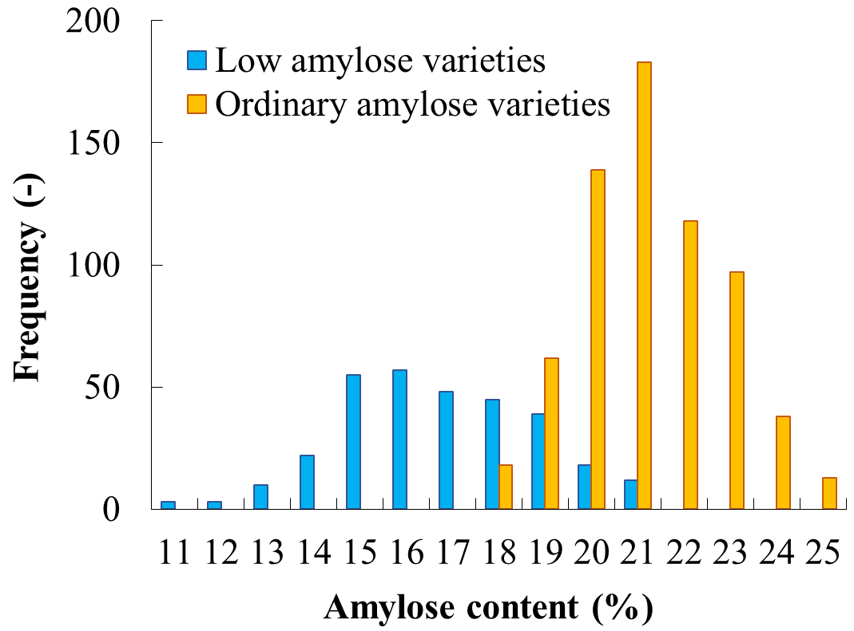

Figure 1. An example of a chart from Excel pasted here using Enhanced Metafile.

## Tables

Use the Table Caption style for the caption and Table Contents for the table.

Avoid tables with too many columns. A table should usually be designed to have more rows than columns.

Table 1. An example of table.

|  |  |  |  |
| --- | --- | --- | --- |
| Category | Test 1  Length (mm) | Test 2  Length (mm) | Test 3  Length (mm) |
| Class 1 | 896 | 882 | 789 |
| Class 2 | 1,826 | 2,245 | 2,258 |
| Class 3 | 457 | 547 | 354 |
| Class 4 | 980 | 1,058 | 1,188 |

## In-text citations

The author-year style should be used for in-text reference citations. More than one reference from the same author(s) in the same year must be identified by the letters “a”, “b”, “c”, etc., placed after the year of publication.

For single author references, use the author’s name (without initials, unless there is ambiguity) and the year of publication.

For two-author references, use both authors’ names and the year of publication.

For references with three or more authors, use the first author’s name followed by ‘et al.’ and the year of publication.

Citations may be made parenthetically or directly, e.g., “…as already demonstrated in several publications (Smith, 2016a, 2016b, 2019; Wang and Jones, 2020). Recently, Liu et al. (2021) have also shown that...”

## Units and numbers

The SI (metric) units and SI derived units should be used. More information about these units can be found in <http://physics.nist.gov/cuu/Units/units.html>.

Express the SI derived units or other units in exponent form with spaces between the elements of the derived unit, e.g., 1.5 kg d-1 and 0.3 g m-2 d-1. Use a comma for five-digit and larger numbers, e.g., 10,000 kg (not 10000 kg).

# Conclusions

Type your research findings here in the Conclusions section.

Acknowledgements

Acknowledgements, if any, can be placed here.

References

Make sure that all the cited references are listed here and all the listed references are cited in the extended abstract. Using of publication DOI is encouraged.

References should be arranged alphabetically and then sorted chronologically if necessary. The following reference arrangements should be used:

Journal articles:

Schmugge, P., and Andre,J.C.,2020. Land Surface Evaportation. Spring-Verlag, p35.

Fast,J.D.,Zong,S.,Whiteman,C.D.,1996. Boundary layer evolution with in a canyonland basin. J.Appl. Meteor.,35(12),2162-2178

Books;

Maruyama, T.,Utsugi, M., Isozaki, T., Nishida,T. 1990. New Edition of Irrigation and Drainage, Vol.1, Yokendo, p7.

Internet resources;

Technical Sections of PAWEES (International Commission of Agricultural Engineering). https://pawees.org/Technical_Sections_overview Accessed November 2, 2021.

This extended abstract template was updated on

April 11, 2025